**ONLINE GROCERY STORE**

**MINI PROJECT REPORT – IT 323**

**BACHELOR OF TECHNOLOGY**

**IN**

**COMPUTER SCIENCE AND ENGINEERING**

**By**

**Shahid Afridi Saikia**

**Roll no: 190103007**

**Himangshu Baruah**

**Roll no: 190103015**

**UNDER THE GUIDANCE OF**

**Satyajit Sarmah**

**Assistant Professor, Dept of IT, GUIST**



**DEPARTMENT OF INFORMATION TECHNOLOGY**

**GAUHATI UNIVERSITY**

**GUWAHATI, INDIA**

**JUNE- 2022**



**GAUHATI UNIVERSITY**

**DEPARTMENT OF INFORMATION TECHNOLOGY**

**Gopinath Bordoloi Nagar, Jalukbari Guwahati-781014**

**DECLARATION**

We “***Shahid Afridi Saikia***”, Roll No “***190103007***”and “***Himangshu Baruah***”, Roll No “***190103015***” , B.Tech. students of the department of Information Technology, Gauhati University hereby declares that we have compiled this report reflecting all the works during the semester long full time project as part of the B.Tech curriculum.

We declare that we have included the descriptions etc. of my project work, and nothing had been copied/replicated from other’s work. The facts, figures, analysis, results, claims etc. depicted in the thesis are all related to the full time project work.

We also declare that the same report or any substantial portion of this report has not been submitted anywhere else as part of any requirements for any degree/diploma etc.

(Shahid Afridi Saikia)

Branch: CSE

Date: 04/07/2022

(Himangshu Baruah)

Branch: CSE

Date: 04/07/2022



GAUHATI UNIVERSITY

**DEPARTMENT OF INFORMATION TECHNOLOGY**

**Gopinath Bordoloi Nagar, Jalukbari Guwahati-781014**

Date:

**CERTIFICATE**

This is to certify that “**Shahid Afridi Saikia**” bearing Roll No: “***190103007***” and “**Himangshu Baruah**” bearing Roll No: “***190103015***” have carried out the project work “***Grocery Delivery System***” under my supervision and has compiled this report reflecting the candidate’s work in the semester long project. The candidate did this project full time during the whole semester under my supervision, and the analysis, results, claims etc. are all related to his/her studies and works during the semester.

I recommend submission of this project report as a part for partial fulfillment of the requirements for the degree of Bachelor of Technology in Information Technology/Computer Science & Engineering of Gauhati University.

([**Satyajit Sarmah**](https://gauhati.ac.in/member/satyajit-sarmah?aid=NA==&did=MzA=))

(Guides affiliation)

**Acknowledgments**

It gives us a great sense of pleasure to present the report of the Project Work undertaken during B. Tech. 6th Sem Project. We owe special debt of gratitude to our Project Guide Mr. Satyajit Sarmah, Department of Information Technology, Gauhati University for his constant support and guidance throughout the course of our work. We also do not like to miss the opportunity to acknowledge the contribution of all faculty members of the department for their kind assistance and cooperation during the development of our project. Last but not the least, we acknowledge my friends for their contribution in the completion of the project.

Shahid Afridi Saikia

190103007

Himangshu Baruah

190103015

**Abstract**

Online grocery shopping is a supermarket that allows online purchasing of fruits, vegetables etc. We can conveniently computer to place your order online .We can select your choice of fruits and vegetable from the grocery store .once We have finalized the order, then you can add an item to the shopping cart. When you checkout from shopping cart, then you order will be develop at the doorstep. When you are satisfied with this order, service and quantity then you pay cash on the spot upon delivery.

* Admin has monitor everything in online grocery shop
* Admin can add ,delete and update the grocery item(fruits and vegetable etc)
* Admin can verify the orders of the online shop
* The user can view the grocery shop item(fruits ,vegetables etc)

**Table of contents**

|  |  |  |
| --- | --- | --- |
| **Sl.No** | **Title** | **Pg.no** |
| **1** | List of tables | **6** |
| **2** | Introduction, figures(DFD) | **7-8** |
| **3** | Background/ Review of literature | **9** |
| **4** | Methodology /System Architecture | **10** |
| **5** | Propose Solution for your problem/Implementation | **11-14** |
| **6** | Conclusion and Future Works | **15** |
| **7** | References | **16** |

**Introduction**

The Internet provides consumers with a new medium of obtaining useful information and for purchasing goods, information and services. The main purpose of GROCERY DELIVERY SYSTEM is to create and develop new models, and to optimize the relationships between a grocery company and its customers. Changing from shopping at the supermarket to online grocery shopping can improve an online grocery retailer’s productivity by shortening supply chains, reducing overhead costs, and enabling “just in time” service.

Delivery of products at the doorstep has become a convenient option for employees who are working remotely, as well as a number of other categories of population, such as people who have to manage both work and also have parental obligations, and also those who are at risk of some major complications by way of COVID-19. The food industry and related services were negatively impacted when pandemic hit the world. The "GROCERY DELIVERY SYSTEM" replace the traditional way of taking orders with computerized system. It is a user-friendly, secure, reliable and fast management system. The System will have better resource management. Thus, it will help organization in better utilization of resources. The purpose of the project is to build an application program to reduce the manual work for managing the Food, Item Category, Contact Address and Newsletter. Online Grocery Delivery System is a very user-friendly project. The user interface of the project is very simple. This application is helping Grocery sellers and their customers to maintain the stock and cash flows and there are many more functionalities, like.

• To store records.

• Control orders and services.

• Control stuff and their shifting.

• Control multiple branches.

## **Flow Diagram of Online Grocery Shop System**

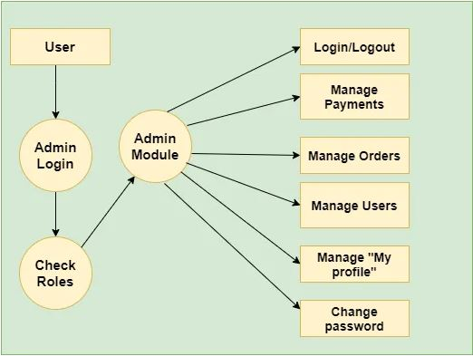

User Module

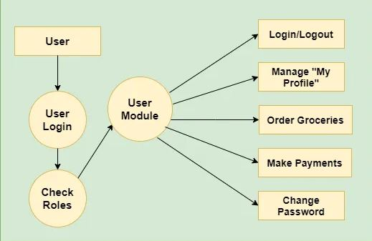

**Background/ Review of literature**

An online grocery menu is set up by the proposed grocery ordering system and as per their will customers can easily place the order. Also, customers can easily track the orders with the menu. The management improve delivery service and preserves customers database. Motivation to develop the system is from the ordering management system. To get the services efficiently the users of the system provide various facilities. Restaurants as well as Mess facility is considered by our system for the customers. Mostly mess users are person who are shifted to new cities and this can be considered as a motivation to our system. Another motivation can be considered as the increasing use of smart phones by the customers, so that any users of this system get all service of the system. The objective of software planning is to provide a frame work that enables the manager to make reasonable estimates made within a limited time frame at the beginning of the software project and should be updated regularly as the project progresses. The main objective of the Project on Ordering System is to manage the details of Grocery, Item Category, Shopping Cart, Contact, Deals. The purpose of the project is to build a web program to reduce the manual work for managing the Item Category, Contact Address, Newsletter. It tracks all the details about the Shopping Cart, Customer, Order.

**Methodology /System Architecture**

**Available Features**

**Admin Panel**

On the other hand, an admin has full control over the system. An admin has the right to manage the proper flow of the system. He/she can manage the food category by entering category names, photos, and selecting access features. For this, an admin has to enter item name, description, price, photo, and select access features. These access features include whether the system will feature the item on the client-side as well as its active class. Now, after setting up everything, an admin can view all the Grocery orders under the Orders section. All the orders that have been made from the client side are presented here.

**Grocery Management, User Management and Overview**

Under the orders section, the system displays all the orders with their respective names, dates, customer details, and status. The system represents such orders and differentiates them with different colours. The admin can overview the records of a total number of categories, items, orders, cancelled orders, pending orders. In addition to it, an admin can check for total revenue generated from the delivered food orders. Last but not least, a clean and simple dashboard is presented with simple colour combinations for greater user experience while using this Grocery Delivery System Project in Node.js and MongoDB. For its UI elements, it fully uses HTML,Javascript and CSS framework i,e Bootstrap. Presenting a new Grocery Delivery System Project in Node.js and MongoDB Project which includes an admin panel with a client-side that contains all the essential features like contact details, and a knowledgeable resource for learning purposes.

**Propose Solution for your problem/Implementation**

We created a “Online Grocery Delivery System” which is a user-friendly, secure, reliable and fast management system and it’s minimized manual data entry, minimize time needed for the various processing, greater efficiency, better service, user friendliness and interactive, minimize time required.

**Implementation**

After opening the website, we can see list of grocery products which we can place order.

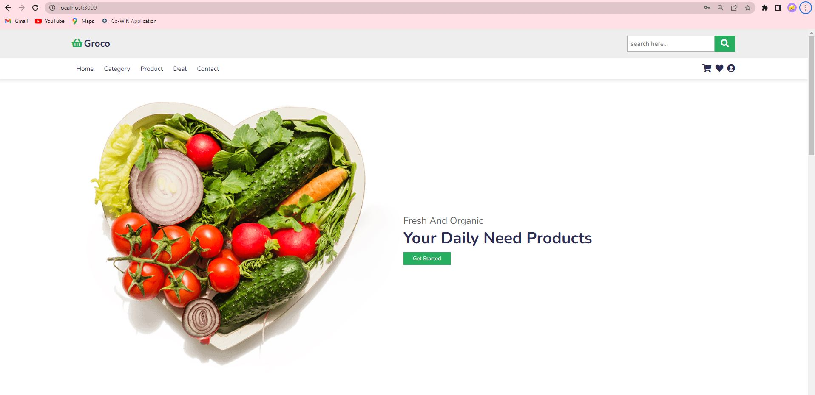

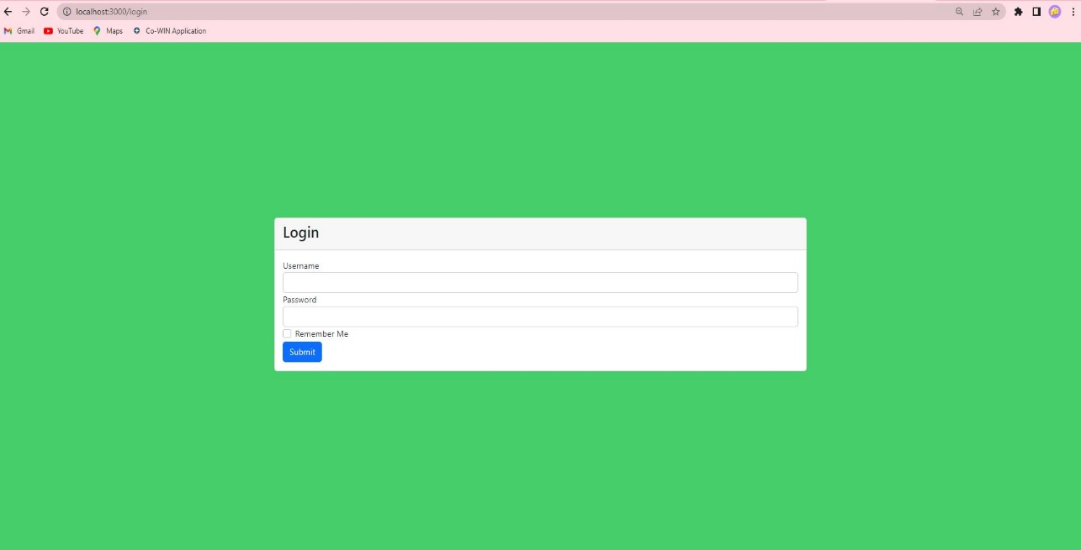Login Page:

Products:

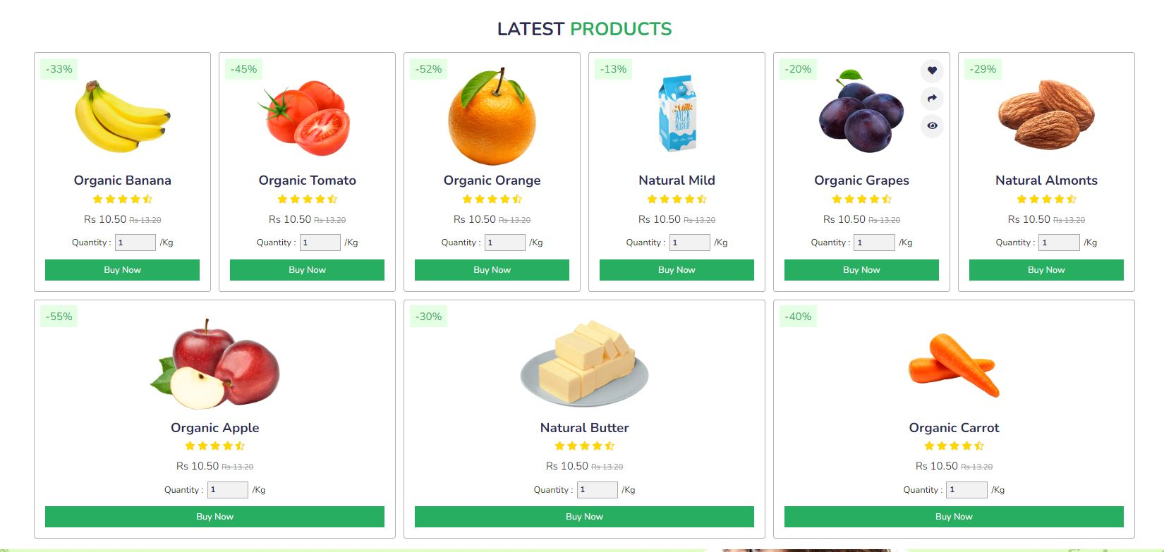

Contact Us and Newsletter

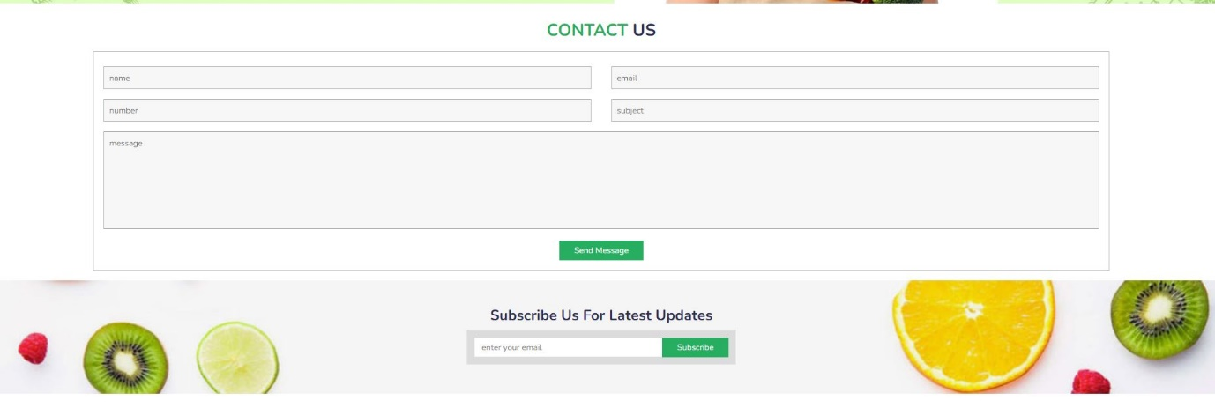

Backend implementation

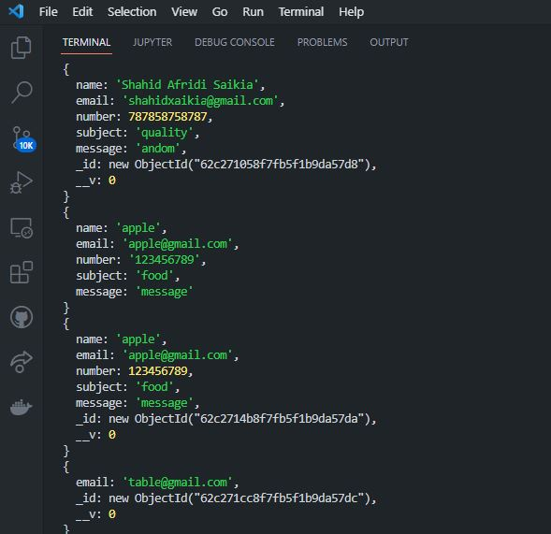

Implementation in MongoDB Compass

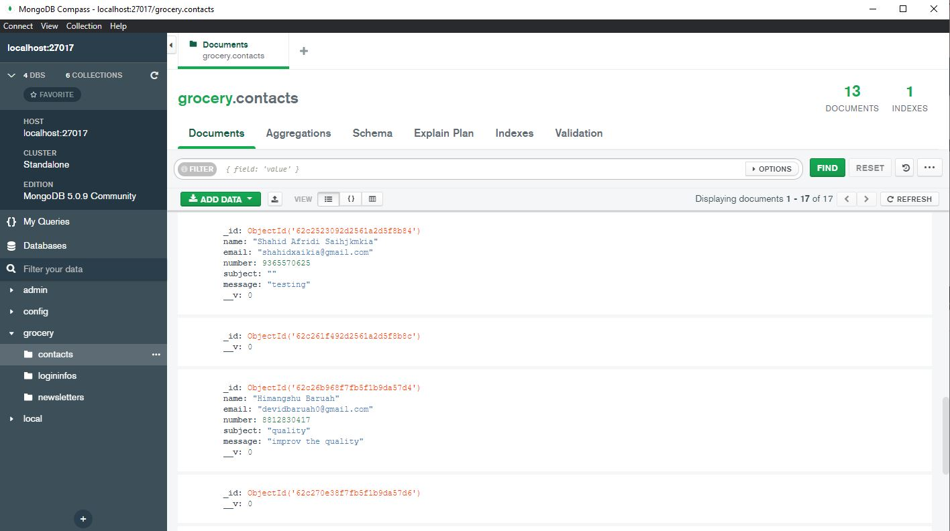

Admin Login Page



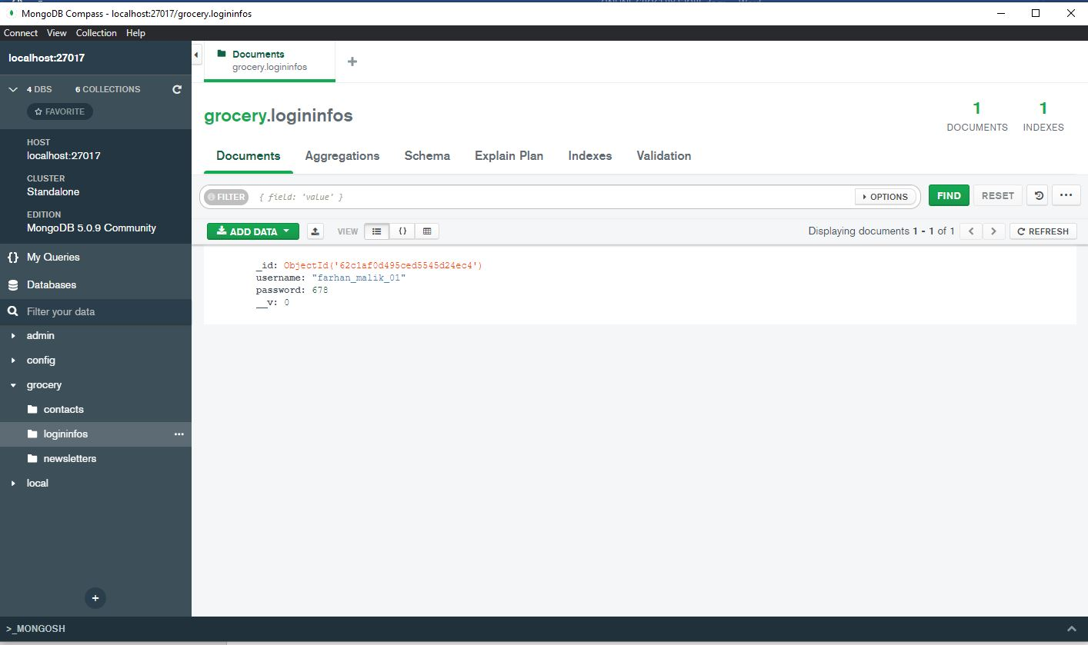

**Conclusion:**

Our project is only a humble venture to satisfy the needs to manage their project work. Several user-friendly coding has also adopted. This package shall prove to be a powerful package in satisfying all the requirements. The objective of software planning is to provide a frame work that enables the manger to make reasonable estimates made within a limited time frame at the beginning of the software project and should be updated regularly as the project progresses.

Future Work:

* We can give more advance software for Grocery Delivery System including more facilities like tracking of the delivery for the users.
* We will host the platform on online servers to make it accessible worldwide.
* We can add payment method.
* We can authorize the seller client to log in, update, create and delete items.

**Reference**

[1] Youtube: <https://www.youtube.com/c/CodeWithHarry>

[2] Udemy: <https://www.udemy.com/course/the-complete-web-development-bootcamp/>

[3] Google: [www.google.com](http://www.google.com)